RAJALAKSHMI ENGINEERING COLLEGE
(AUTONOMOUS), CHENNAI

FUNDAMENTALS OF DATA AND VISUAL ANALYTICS
AD23632

SOCIAL MEDIA DATA ANALYTICS
MINI-PROJECT REPORT

SUBMITTED BY
GOPIKA V
ROLL NUMBER: 241501058

in partial fulfillment of the requirements for the course
BACHELOR OF TECHNOLOGY
in
ARTIFICIAL INTELLIGENCE AND MACHINE LEARNING
DEPARTMENT OF ARTIFICIAL INTELLIGENCE AND MACHINE LEARNING
RAJALAKSHMI ENGINEERING COLLEGE (AUTONOMOUS)
CHENNAI – 602 105

2026

ABSTRACT
This project studies a social media dataset containing 1,000 records. The data is examined using Python to understand platform usage, user age groups, device preferences, video categories, engagement, satisfaction and productivity loss. Charts are created to make the main patterns easier to understand. The existing Power BI dashboard is included and discussed, and the same data is used to explain how similar charts can be created in Tableau. The report describes the dataset, the steps followed for analysis, the charts and their findings, and the main conclusions. The results describe only the records provided in the dataset.

TABLE OF CONTENTS
1. Introduction
2. Problem Statement and Objectives
3. Dataset Description
4. Methodology and Data Preparation
5. Python-Based Data Analysis and Visualisation
6. Power BI Dashboard: Design and Interpretation
7. Tableau Visualisation: Proposed Implementation
8. Results and Discussion
9. Conclusion and Future Scope
References
Appendix A – Python Code
Appendix B – Tableau Build Checklist

1. INTRODUCTION

1.1 Background
Social media platforms generate substantial volumes of user interaction data. A structured analysis of such data can help describe platform preference, time spent, session frequency, engagement, video-category interest, device usage and self-reported outcomes such as satisfaction or productivity loss. Visual analytics translates these variables into charts and dashboards that make patterns easier to inspect than raw spreadsheets.

1.2 Project Overview
This project analyses a supplied social media dataset and communicates its patterns through three tools: Python for data inspection and statistical visualisation, Microsoft Power BI for an interactive dashboard, and Tableau as a second dashboarding environment. The existing Power BI screenshot is retained as the baseline visual reference. Python charts are generated from the actual Excel data. A Tableau workbook design and step-by-step build instructions are included for implementation.

1.3 Need for the Project
- Raw tabular data makes it difficult to compare multiple categories at once.
- Platform usage, video-category engagement and productivity-related scores are easier to interpret visually.
- Consistent measures and labels help reduce ambiguity when communicating analytical findings.
- Using Python alongside BI tools provides both reproducible analysis and accessible dashboard presentation.

1.4 Scope
The scope is descriptive and exploratory. It includes data profiling, summary statistics, category comparisons and dashboard design. The data does not establish causality, and the dataset's provenance and measurement definitions were not supplied with the workbook. Therefore, results are presented as patterns in the provided records rather than as general claims about all social media users.

2. PROBLEM STATEMENT AND OBJECTIVES

2.1 Problem Statement
The supplied social media dataset contains demographic, usage, engagement and self-reported outcome variables across 1,000 records. Without structured analysis and visual representation, it is difficult to identify which platforms appear most frequently, which video categories contribute the highest total engagement values, how user records are distributed across age groups and devices, and how productivity-loss scores vary by profession. The project addresses this communication problem by converting the dataset into clear Python charts and a Power BI dashboard, with a Tableau design for parallel visual exploration.

2.2 Objectives
- Inspect the dataset structure, column types, completeness and duplicate records.
- Summarise the distribution of social media platforms, age groups, devices and viewing reasons.
- Compare total engagement across video categories and productivity-loss score totals across professions.
- Create reproducible visualisations using Python, Pandas and Matplotlib.
- Document the supplied Power BI dashboard, explain its current visuals and recommend focused improvements.
- Specify how equivalent charts, filters and calculated fields can be created in Tableau.
- Present findings with appropriate caveats and avoid causal conclusions unsupported by the data.

2.3 Expected Outcome
The expected outcome is a documented analysis and visual analytics workflow that enables a reader to understand the structure of the dataset, inspect major distributions and category comparisons, and reproduce the visualisations in Python, Power BI and Tableau.

3. DATASET DESCRIPTION

3.1 Dataset Overview
The workbook contains multiple sheets. For this report, the worksheet named “socialmedia (1) (1) (1)” was selected because it contains the structured social media records. It has 1,000 rows and 31columns. The UserID field ranges from 1 to 1000. The selected sheet is treated as the analysis table; other workbook sheets were not merged because their relationship to the selected table is not documented.

3.2 Attribute Groups
Attribute group | Fields | Description
Identifiers | UserID, Video ID | Record/video identifiers; not measures of performance.
Demographics | Age, Gender, Location, Income, Debt, Owns Property, Profession, Demographics | User profile and background fields.
Platform and usage | Platform, Total Time Spent, Number of Sessions, Frequency, Watch Time, CurrentActivity | Platform choice and usage context.
Video behaviour | Video Category, Video Length, Time Spent On Video, Number of Videos Watched, Scroll Rate, Watch Reason | Content and viewing behaviour.
Engagement and outcomes | Engagement, Importance Score, ProductivityLoss, Satisfaction, Self Control, Addiction Level | Numeric scores requiring careful interpretation.
Device and connection | DeviceType, OS, ConnectionType | Technology used to access the platform.

3.3 Selected Column Definitions
Field | Interpretation used in this report
Platform | Named platform associated with a record.
Total Time Spent | Numeric measure of time spent; the workbook does not specify its unit.
Number of Sessions | Count of sessions recorded for a user.
Engagement | Numeric engagement value; its exact construction is not documented.
Video Category | Category assigned to the viewed video.
ProductivityLoss | Numeric score related to productivity loss; unit and scale interpretation are not supplied.
Satisfaction | Numeric satisfaction score.
Self Control / Addiction Level | Numeric scores; the dataset documentation does not define scale anchors.

3.4 Data Quality Profile
Check | Result
Rows in selected worksheet | 1,000
Columns in selected worksheet | <docx.text.paragraph.Paragraph object at 0x7f4419496590>
Missing cells in selected worksheet | 0
Exact duplicate complete rows | 0
Age range | 18–64
Distinct platforms | 4
Distinct video categories | 9
Distinct professions | 9
All selected-sheet cells are populated in the current import. This does not guarantee that every value is valid or semantically correct. Further checks should verify allowed category labels, score ranges, numeric outliers and the meaning/units of time fields. UserID is an identifier and should not be aggregated as a metric.

4. METHODOLOGY AND DATA PREPARATION

4.1 Workflow
- Load the selected worksheet from the Excel workbook.
- Inspect dimensions, column names, data types, descriptive statistics and missing values.
- Check exact duplicate rows and review categorical value counts.
- Create an age-group field for grouped demographic summaries.
- Aggregate records by platform, video category, profession, device and watch reason.
- Generate charts with clear titles, labels and captions.
- Use the supplied Power BI dashboard as the baseline and document visual improvements.
- Map the same analytical questions to Tableau worksheets and dashboard components.

4.2 Data Preparation Decisions
The analysis uses the selected worksheet without merging other workbook tabs. The age groups used for one chart are 18–24, 25–34, 35–44, 45–54 and 55–64. Platform and category summaries use value counts or sums of the available numeric fields. For ProductivityLoss by Profession, the chart displays the sum of the recorded scores; it is not a per-person rate. A mean-by-profession chart can be added if a fairer comparison across groups of different sizes is required.

4.3 Limitations of Measurement
The workbook does not provide a data dictionary, collection method, survey instrument, sampling procedure, date field or explicit units for time. The report therefore avoids assigning minutes to Total Time Spent unless independently confirmed. Engagement values are treated as numeric scores as stored. Correlation is used only as a descriptive diagnostic and cannot establish causation.

5. PYTHON-BASED DATA ANALYSIS AND VISUALISATION

5.1 Tools and Libraries
Python provides a reproducible workflow. Pandas loads and aggregates the Excel data; Matplotlib creates charts. NumPy may be used for numerical operations. The code below is intended to run in Jupyter Notebook or another Python environment with pandas, openpyxl, matplotlib and numpy installed.

5.2 Load and Inspect the Dataset
import pandas as pd
import matplotlib.pyplot as plt

file_path = "socialmedia (1) (1) (1)(1).xlsx"
df = pd.read_excel(file_path, sheet_name="socialmedia (1) (1) (1)")

print("Shape:", df.shape)
print(df.head())
print(df.info())
print(df.isna().sum().sort_values(ascending=False).head(10))
print(df.describe(include="all"))
Observed result: the selected worksheet has 1,000 records and 31 columns. The import contains 0 missing cells and 0 exact duplicate rows under an all-column comparison.

5.3 Platform Distribution
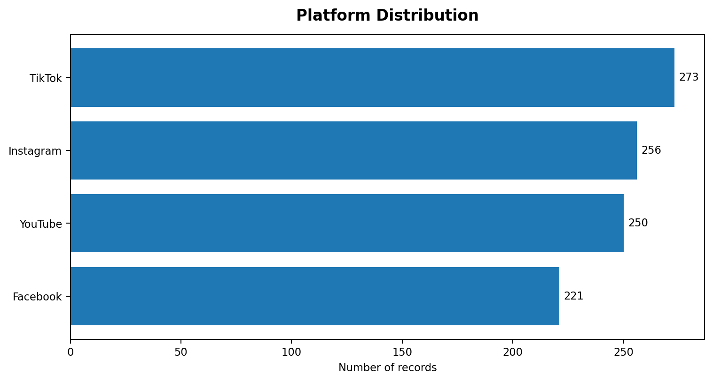
Figure 1. Number of records by social media platform.
TikTok has the largest number of records (273), followed by Instagram (256), YouTube (250) and Facebook (221). The distribution is relatively spread across the four platforms; the chart counts records rather than measuring market share in the general population.

5.4 Engagement by Video Category
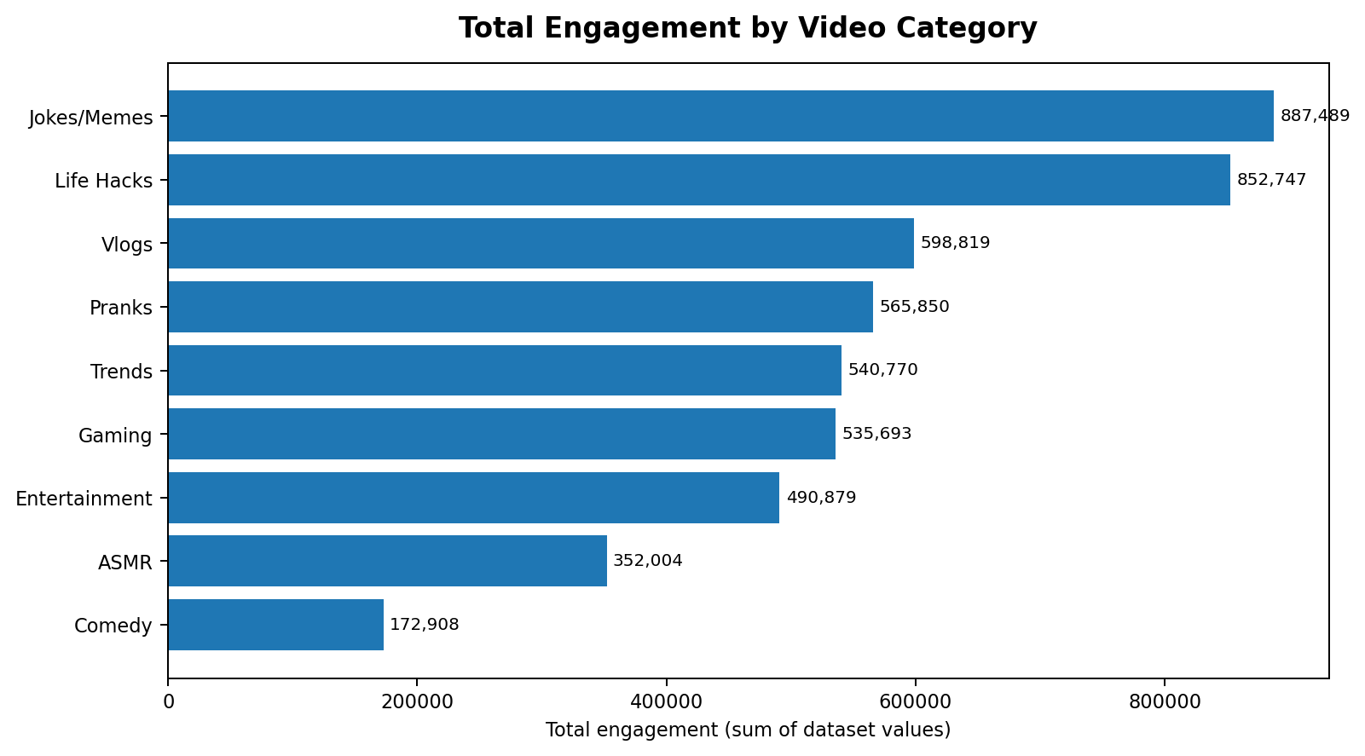
Figure 2. Sum of Engagement values by video category.
Jokes/Memes has the highest total engagement value (887,489), followed by Life Hacks (852,747). Comedy has the lowest total among the listed categories (172,908). Because category totals depend on the number of records as well as the values, a complementary mean-engagement chart should be considered when comparing typical category performance.
category_summary = (
df.groupby("Video Category")["Engagement"]
.agg(["count", "sum", "mean"])
.sort_values("sum", ascending=False)
)
print(category_summary)

5.5 Age Group Distribution
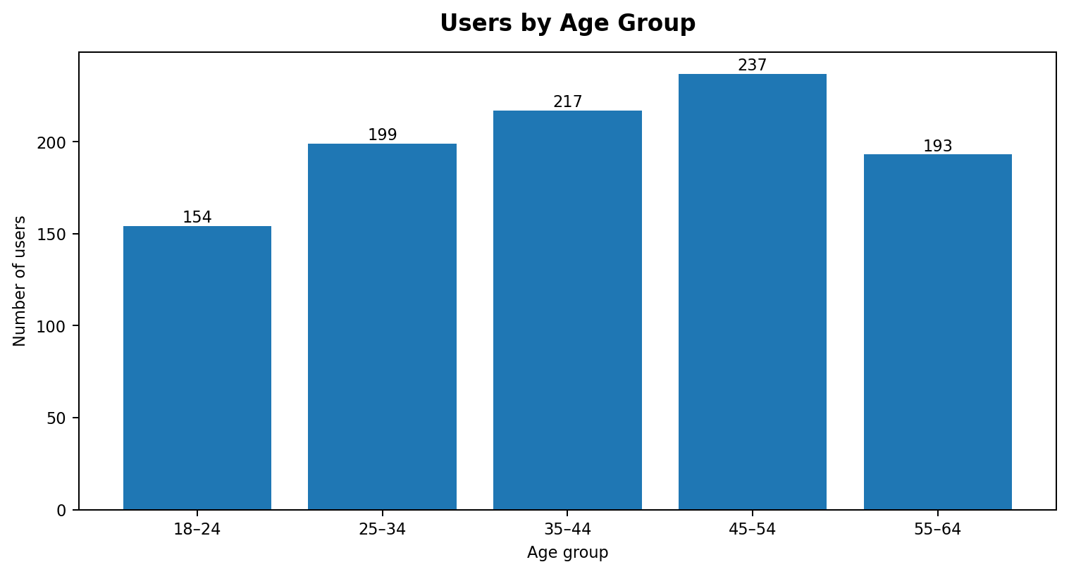
Figure 3. Number of records in each age group.
The largest age group in the current dataset is 45–54 (237 records), while 18–24 has 154 records. Age grouping simplifies comparisons but discards within-group detail, so the original Age column should remain available for deeper analysis.

5.6 Device Type Share
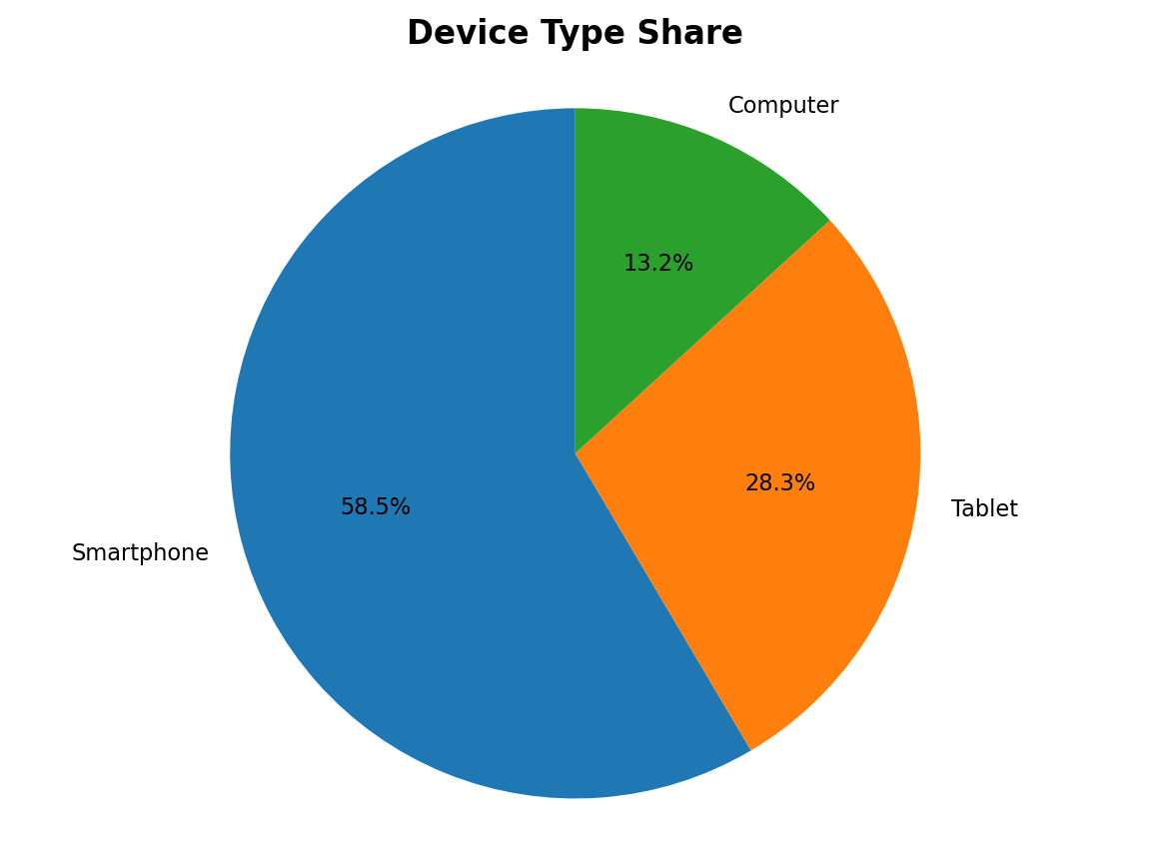
Figure 4. Distribution of records by device type.
Smartphones account for 585 records (58.5%), tablets for 283, and computers for 132. This indicates that smartphone records dominate the supplied sample. It should not be interpreted as a universal device-use estimate.

5.7 Productivity Loss Score by Profession
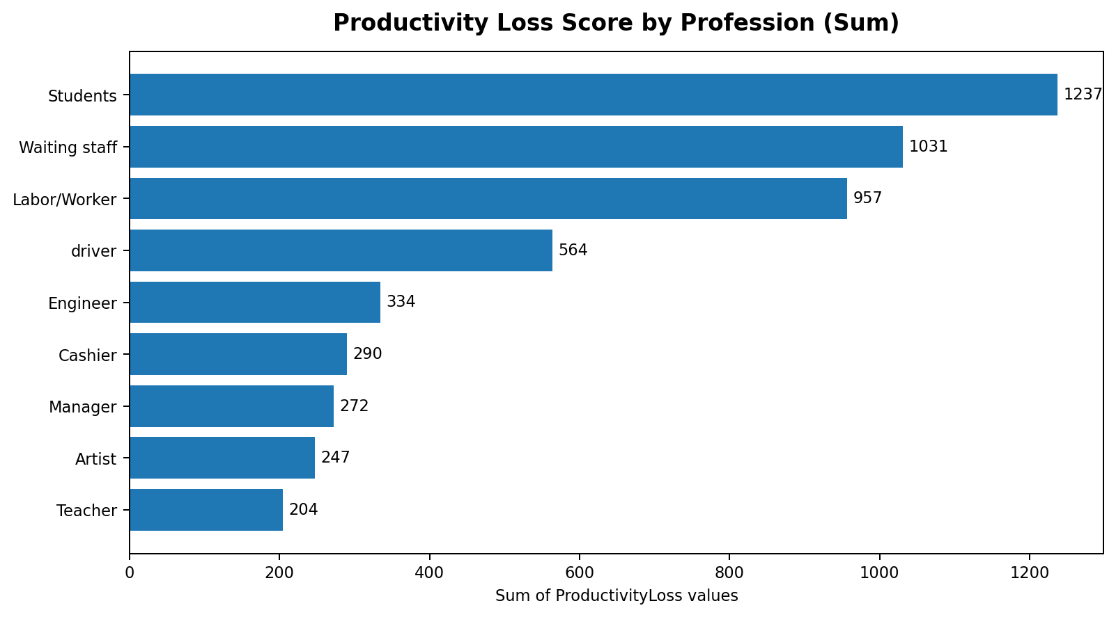
Figure 5. Sum of ProductivityLoss scores by profession.
Students have the highest sum of ProductivityLoss scores (1,237), followed by Waiting staff (1,031) and Labor/Worker (957). Profession groups contain different numbers of records, so the total reflects both group size and score values. For a like-for-like comparison, use mean ProductivityLoss alongside record count.
profession_summary = (
df.groupby("Profession")["ProductivityLoss"]
.agg(record_count="count", total_score="sum", mean_score="mean")
.sort_values("mean_score", ascending=False)
)
print(profession_summary.round(2))

5.8 Platform Metric Comparison
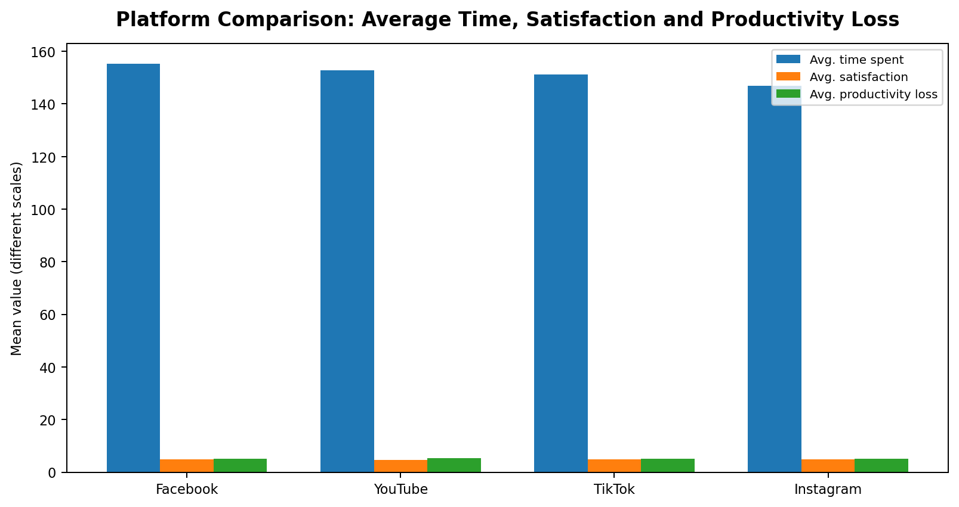
Figure 6. Platform-level averages. Note that time and scores use different scales.
The combined chart places time and score measures on the same display, so it is useful for a quick overview but not for comparing bar heights across unlike units. A polished dashboard should separate average time from satisfaction and productivity-loss scores, or use small multiples. In the current dataset, the highest average Total Time Spent is associated with Facebook (155.18), while YouTube has the lowest mean Satisfaction (4.74) among these platform averages.

5.9 Reasons for Watching
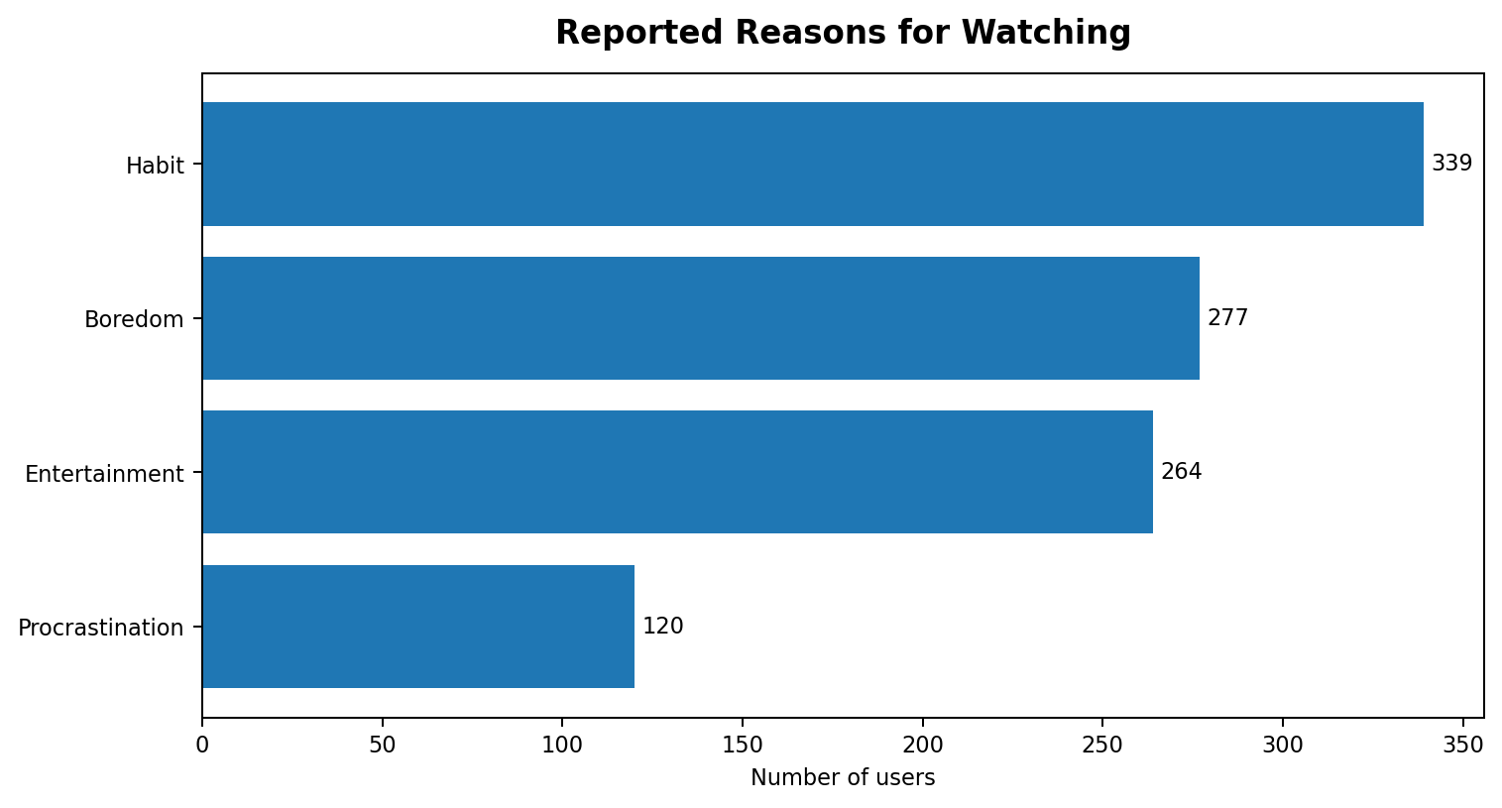
Figure 7. Number of records by reported watch reason.
Habit is the most frequently recorded watch reason (339), followed by Boredom (277) and Entertainment (264). Procrastination is the least frequent of the listed reasons. These are recorded categories, not a diagnosis of individual behaviour.

5.10 Correlation Matrix
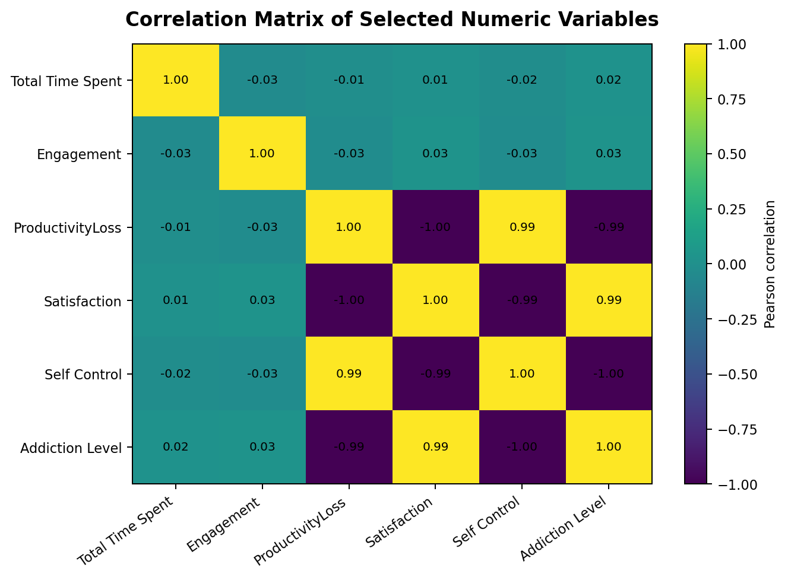
Figure 8. Pearson correlations among selected numeric fields.
The matrix is a descriptive check of linear association. Some outcome scales in the dataset show very strong inverse or direct relationships, including relationships between ProductivityLoss, Satisfaction, Self Control and Addiction Level. Such near-perfect associations may arise from how the values were constructed or encoded. The original scale definitions should be verified before drawing substantive conclusions. Correlation does not establish that one variable causes another.

5.11 Reproducible Chart Example
import matplotlib.pyplot as plt

platform_counts = df["Platform"].value_counts().sort_values()
fig, ax = plt.subplots(figsize=(8, 4.5))
ax.barh(platform_counts.index, platform_counts.values)
ax.set_title("Platform Distribution")
ax.set_xlabel("Number of records")
ax.set_ylabel("Platform")
fig.tight_layout()
plt.show()

6. POWER BI DASHBOARD: DESIGN AND INTERPRETATION

6.1 Existing Dashboard
The following image is the dashboard screenshot supplied for this project. It contains three KPI cards and four visualisations: platform usage as a pie chart, average time spent by age as a line chart, total engagement by video category as a column chart, and summed ProductivityLoss by profession as a scatter chart.
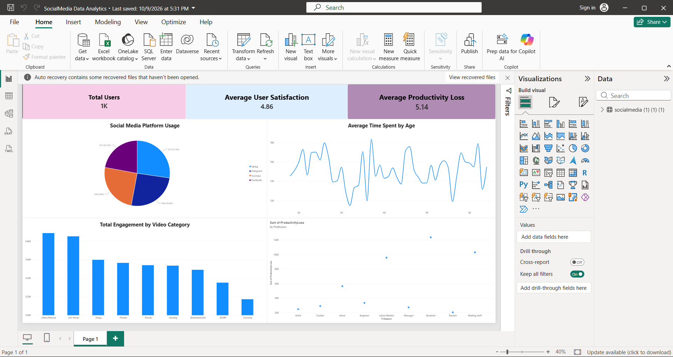
Figure 9. Existing Social Media Data Analytics created in Microsoft Power BI.

6.2 KPI Cards
Card | Displayed value | Interpretation
Total Users | 1K | The current dashboard shows approximately 1,000 user records. If UserID is one row per user, label as Total Users; otherwise use Total Records.
Average User Satisfaction | 4.86 | Matches the dataset mean Satisfaction (approximately 4.864). Include the score range if confirmed by the data dictionary.
Average Productivity Loss | 5.14 | Matches the dataset mean ProductivityLoss (approximately 5.136). The score unit/scale is not defined in the workbook.

6.3 Current Visuals
Visual | What it communicates | Suggested improvement
Social Media Platform Usage – pie | Share/count distribution across TikTok, Instagram, YouTube and Facebook. | Keep if the purpose is share; add data labels with counts and percentages, and sort consistently.
Average Time Spent by Age – line | Shows values across ages, but the connected line may imply continuity between individual ages. | Use a scatter plot or average time by age-group column chart; if keeping the line, aggregate by age and label the measure/unit.
Total Engagement by Video Category – columns | Compares engagement totals across video categories. | Sort descending; add tooltip with record count and mean engagement to separate volume from typical engagement.
Sum of ProductivityLoss by Profession – scatter | Shows total score by profession. | Prefer a horizontal bar chart, include record count, and optionally show average score for fairer group comparison.

6.4 Recommended Dashboard Layout
- Top row: Total Users/Records, Average Time Spent, Average Satisfaction, Average ProductivityLoss.
- Middle-left: platform usage (bar or donut); middle-right: average engagement by video category.
- Bottom-left: average ProductivityLoss by profession with record count in tooltip.
- Bottom-right: age-group distribution or device-type distribution.
- Add slicers for Platform, Age Group, Gender, Profession and DeviceType.
- Use consistent number formatting, descriptive titles, alt text where available, and a small note explaining score units.

6.5 Suggested DAX Measures
Assuming the imported table is named SocialMedia and column names match the workbook, the following measures can be created in Power BI. If Power BI names the table differently, replace the table name.
Total Records = COUNTROWS(SocialMedia)

Average Time Spent = AVERAGE(SocialMedia[Total Time Spent])

Average Engagement = AVERAGE(SocialMedia[Engagement])

Average Satisfaction = AVERAGE(SocialMedia[Satisfaction])

Average Productivity Loss = AVERAGE(SocialMedia[ProductivityLoss])

Average Sessions = AVERAGE(SocialMedia[Number of Sessions])

6.6 Dashboard Interpretation
The dashboard is a useful single-page summary of platform, engagement and profession-level patterns. It can be improved by distinguishing totals from averages, displaying denominators for category comparisons, and avoiding a line chart where the x-axis is an unaggregated age value. The supplied screenshot is preserved as the existing implementation; the recommendations above describe enhancements rather than claiming they have already been applied.

7. TABLEAU VISUALISATION: PROPOSED IMPLEMENTATION

7.1 Purpose
Tableau is included as a parallel visual analytics tool. No Tableau dashboard was supplied, so this chapter documents a reproducible build plan based on the same Excel dataset. It is an implementation guide, not evidence of a completed Tableau workbook.

7.2 Connect to the Excel Dataset
- Open Tableau Desktop or Tableau Public and select Microsoft Excel from Connect.
- Choose the supplied social media workbook.
- On the Data Source page, select the worksheet “socialmedia (1) (1) (1)” containing the 1,000-row table.
- Confirm data types: Age, Total Time Spent, Engagement, Satisfaction and ProductivityLoss should be numeric; Platform, Profession, Video Category and DeviceType should be dimensions.
- Rename the data source to Social Media Data Analytics. Do not combine unrelated workbook tabs unless their relationship is confirmed.

7.3 Recommended Worksheets
Worksheet | Build instructions | Purpose
Platform Distribution | Drag Platform to Rows and Number of Records to Columns; sort descending; choose horizontal bars; show labels. | Compare record counts by platform.
Engagement by Category | Drag Video Category to Rows and SUM(Engagement) to Columns; sort descending; show labels. | Identify categories with the largest total engagement values.
Mean Engagement by Category | Use AVG(Engagement) instead of SUM(Engagement), and add COUNT(Engagement) to tooltip. | Compare typical values while exposing sample size.
Age Group Distribution | Create calculated field Age Group with IF/ELSEIF bands; place Age Group on Columns and Number of Records on Rows. | Summarise the age profile.
Device Type Share | Place DeviceType on Color and Number of Records on Angle/Label in a pie chart, or use bars for easier comparison. | Compare device types.
ProductivityLoss by Profession | Place Profession on Rows and AVG(ProductivityLoss) on Columns; add COUNT(UserID) to tooltip; sort descending. | Compare average scores while considering group sizes.
Platform KPI View | Place Platform on Columns and AVG(Total Time Spent), AVG(Satisfaction), AVG(ProductivityLoss) in separate sheets or a small-multiple layout. | Compare platform-level averages without mixing scales.

7.4 Tableau Calculated Fields
// Age Group
IF [Age] <= 24 THEN "18–24"
ELSEIF [Age] <= 34 THEN "25–34"
ELSEIF [Age] <= 44 THEN "35–44"
ELSEIF [Age] <= 54 THEN "45–54"
ELSE "55–64"
END

// Average Satisfaction
AVG([Satisfaction])

// Average Productivity Loss
AVG([ProductivityLoss])

7.5 Dashboard Assembly
- Create a new dashboard with a fixed or automatic size appropriate for a laptop screen.
- Place KPI sheets across the top: Number of Records, AVG(Total Time Spent), AVG(Satisfaction) and AVG(ProductivityLoss).
- Place Platform Distribution and Engagement by Category in the middle row.
- Place Age Group Distribution and ProductivityLoss by Profession in the bottom row.
- Show filters for Platform, Gender, Profession, DeviceType and Age Group; apply them to all relevant worksheets.
- Use dashboard actions so selecting a platform filters or highlights related views.
- Use concise titles, consistent fonts and a restrained palette. Avoid unnecessary 3-D charts and excessive colours.
- Check every tooltip, axis label, aggregation and filter before exporting the dashboard.

7.6 Tableau Dashboard Interpretation
The proposed Tableau dashboard answers the same questions as the Python analysis and Power BI report, but supports interactive filtering and coordinated views. The main difference is the implementation environment: dimensions and measures are dragged into shelves, calculated fields create age bands, and worksheets are assembled into a dashboard. The final interpretation should be based on the workbook once it is built and checked.

8. RESULTS AND DISCUSSION

8.1 Key Descriptive Results
Measure | Observed result | Interpretation
Number of records | 1,000 | The selected worksheet contains 1,000 records.
Average age | 40.99 | Descriptive average of ages in the sample.
Average Total Time Spent | 151.41 | Time unit is not documented.
Average Engagement | 4997.16 | Numeric engagement field; scale is not documented.
Average Satisfaction | 4.86 | Mean recorded satisfaction score.
Average ProductivityLoss | 5.14 | Mean recorded productivity-loss score.
Average sessions | 10.01 | Mean Number of Sessions.
Average Addiction Level | 2.91 | Descriptive score only; scale definition is not documented.

8.2 Major Patterns
- TikTok has the largest platform record count in the selected worksheet, but the difference between platforms should not be interpreted as market share without sampling information.
- Jokes/Memes and Life Hacks have the largest total Engagement sums. Mean engagement and record count should be reviewed together before ranking category quality.
- Smartphones are the most common device type in the records.
- Habit is the most frequently recorded watch reason.
- Students have the largest summed ProductivityLoss score by profession, but group sizes differ. Average score and record count should be shown together.
- Average satisfaction and productivity-loss scores are close to the values shown in the supplied Power BI KPI cards.

8.3 Interpretation Boundaries
These findings describe the uploaded spreadsheet only. They do not prove that a platform causes productivity loss or that one profession is more negatively affected than another. The data source, sampling method, units and score definitions were not supplied. Strong relationships among some numeric scores may reflect the dataset's construction; they should be checked against original documentation.

9. CONCLUSION AND FUTURE SCOPE

9.1 Conclusion
The project demonstrates a workflow for turning a multi-attribute social media dataset into visual information. Python supports transparent data inspection, aggregation and chart generation. The existing Power BI dashboard provides a concise view of users, satisfaction, productivity loss, platform usage, time spent, engagement and profession-level totals. Tableau can reproduce and extend the analysis through calculated fields, filters and coordinated dashboards. The most important reporting improvement is to distinguish counts, sums and averages and to state the units and limitations of the underlying measures.

9.2 Future Enhancements
- Confirm the source, sampling method and data dictionary for all score and time fields.
- Add validation rules for numeric ranges, inconsistent labels and outliers.
- Compare both mean and median time/engagement measures to reduce sensitivity to extreme values.
- Display category sample sizes alongside sums and averages.
- Use interactive filters and cross-highlighting in Power BI and Tableau.
- Add time-series analysis if reliable date/time observations become available.
- Validate apparent score correlations against the original measurement design before making substantive claims.

REFERENCES
- Supplied Excel workbook: socialmedia (1) (1) (1)(1).xlsx, worksheet “socialmedia (1) (1) (1)”.
- Python Software Foundation. Python documentation. https://docs.python.org/3/
- Pandas documentation. https://pandas.pydata.org/docs/
- Matplotlib documentation. https://matplotlib.org/stable/
- Microsoft Learn. Power BI documentation. https://learn.microsoft.com/power-bi/
- Tableau Help. Tableau documentation. https://help.tableau.com/

APPENDIX A – PYTHON CODE
The following compact script reproduces the primary summaries and selected visualisations. Change file_path to the location of the Excel workbook in your environment.
import pandas as pd
import matplotlib.pyplot as plt

file_path = "socialmedia (1) (1) (1)(1).xlsx"
df = pd.read_excel(file_path, sheet_name="socialmedia (1) (1) (1)")

# Basic profile
print("Shape:", df.shape)
print("Missing cells:", int(df.isna().sum().sum()))
print("Exact duplicate rows:", int(df.duplicated().sum()))
print(df.describe(include="all"))

# Platform distribution
df["Platform"].value_counts().plot(kind="bar", title="Platform Distribution")
plt.xlabel("Platform")
plt.ylabel("Number of records")
plt.tight_layout()
plt.show()

# Engagement by category
(df.groupby("Video Category")["Engagement"].sum()
.sort_values()
.plot(kind="barh", title="Total Engagement by Video Category"))
plt.xlabel("Sum of Engagement")
plt.tight_layout()
plt.show()

# Productivity loss: show both mean and group size
summary = df.groupby("Profession")["ProductivityLoss"].agg(
record_count="count", total_score="sum", mean_score="mean"
)
print(summary.sort_values("mean_score", ascending=False).round(2))

# Age bands
df["Age Group"] = pd.cut(
df["Age"], bins=[17, 24, 34, 44, 54, 64],
labels=["18–24", "25–34", "35–44", "45–54", "55–64"]
)
df["Age Group"].value_counts().sort_index().plot(
kind="bar", title="Users by Age Group"
)
plt.xlabel("Age Group")
plt.ylabel("Number of records")
plt.tight_layout()
plt.show()

APPENDIX B – TABLEAU BUILD CHECKLIST
- Connect to the Excel file and select the correct worksheet.
- Verify field types and aggregation behaviour.
- Create age groups with a calculated field.
- Build platform, category, age, device and profession worksheets.
- Include both SUM(Engagement) and AVG(Engagement) where appropriate.
- Use AVG(ProductivityLoss) and include record count for profession comparisons.
- Build KPI tiles and assemble the dashboard.
- Add global filters and test dashboard actions.
- Verify labels, units, tooltips and score definitions.
- Export the finished Tableau dashboard image and insert it into the report after the Tableau implementation is complete.

